Semester 2 (Unit 3&4) Examination, 2018

Question/Answer Booklet

MATHEMATICS METHODS

Section One: Calculator-free

Student Name/Number: ______________________________________________

Teacher Name: ______________________________________________

Time allowed for this section
Reading time before commencing work: five minutes
Working time for this section: fifty minutes

Materials required/recommended for this section
To be provided by the supervisor: This Question/Answer Booklet
Formula Sheet

To be provided by the candidate:
Standard items: pens (blue/black preferred), pencils (including coloured), sharpener,
correction fluid/tape, eraser, ruler, highlighters
Special items: nil

Important note to candidates
No other items may be taken into the examination room. It is your responsibility to ensure that you do not have any unauthorised notes or other items of a non-personal nature in the examination room. If you have any unauthorised material with you, hand it to the supervisor before reading any further.

Structure of this paper

Section | Number of questions available | Number of questions to be answered | Working time (minutes) | Marks available | Percentage of exam
Section One: Calculator-free | 7 | 7 | 50 | 54 | 35
Section Two: Calculator-assumed | 14 | 14 | 100 | 100 | 65
 |  |  |  |  | 100

Instructions to candidates

- The rules for the conduct of School exams are detailed in the School/College assessment policy. Sitting this examination implies that you agree to abide by these rules.

- Write your answers in this Question/Answer Booklet.

3. You must be careful to confine your responses to the specific questions asked and to follow any instructions that are specific to a particular question.

- Spare pages are included at the end of this booklet. They can be used for planning your responses and/or as additional space if required to continue an answer.
  - Planning: If you use the spare pages for planning, indicate this clearly at the top of the page.
  - Continuing an answer: If you need to use the space to continue an answer, indicate in the original answer space where the answer is continued, i.e. give the page number. Fill in the number of the question that you are continuing to answer at the top of the page.

- Show all working clearly. Your working should be in sufficient detail to allow your answers to be checked readily and for marks to be awarded for reasoning. Incorrect answers given without supporting reasoning cannot be allocated any marks. For any question or part question worth more than two marks, valid working or justification is required to receive full marks. If you repeat any question, ensure that you cancel the answer you do not wish to have marked.

- It is recommended that you do not use pencil, except in diagrams.

- The Formula Sheet is not to be handed in with your Question/Answer Booklet.

Section One: Calculator-free (54 Marks)

This section has (seven) 7 questions. Answer all questions. Write your answers in the spaces provided. Spare pages are included at the end of this booklet.

Suggested working time: 50 minutes.

Question 1 (7 marks)
(a) Evaluate (3 marks)

(b) Given that (2 marks)

(c) Evaluate (2 marks)

Question 2 (7 marks)

The distribution of marks of 150 students in a Semester 2 examination at a local school were found to be normally distributed with a mean and standard deviation
Joanne sat this examination and scored 63%.

Note: In a normal distribution, approximately
68% of the values lie within one standard deviation of the mean
95% of the values lie within two standard deviations of the mean
99.7% of the values lie within 3 standard deviations of the mean

(a) How many students scored above Joanne? (2 marks)

The same examination was sat by students in a nearby school. The results of these students were also normally distributed and reflected a higher mean and lower standard deviation than the students of the first school.

(b) On the axes below draw a clearly labelled diagram that demonstrates the relationship between the distribution of scores in the two schools. (2 marks)
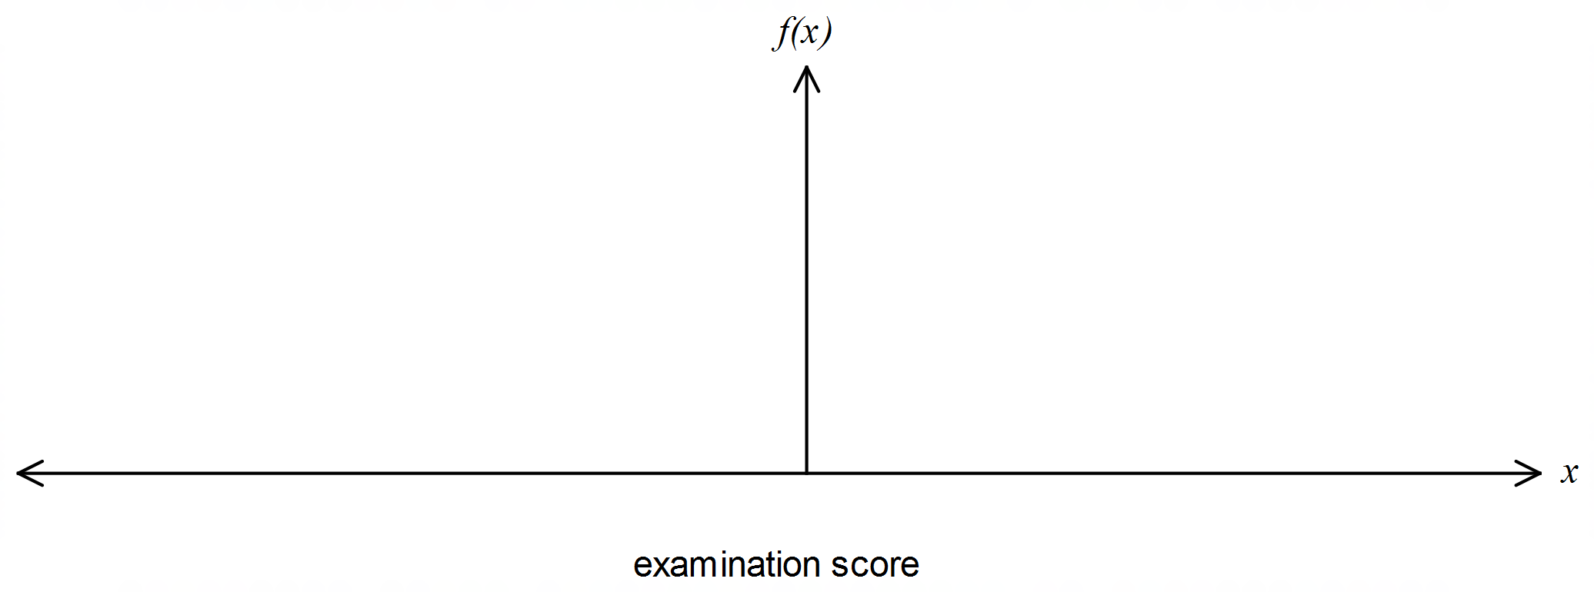

The principal of the first school was not happy with the results of the students and asked that the Mathematics Department scale the scores to ensure that the results reflected a mean of 55% and standard deviation of 6%.

The head of the Mathematics Department applied a linear transformation to the results to obtain Y scores for the students. She used the transformation where X represented the original results of the students and Y, the scaled scores.

(c) Determine the value of a and b. (3 marks)

Question 3 (6 marks)

In a gambling game, Michael is paid $5 if he gets all heads or all tails when 3 coins are tossed and he pays out $3 if either one or two heads show.

- Complete the following probability distribution for the random variable, X, the amount he can win. (2 marks)

x
Probability (X=x)

- What is Michael’s expected gain? Explain your answer. (2 marks)

- Comment on whether this gambling game is “fair” or not. (2 marks)

Question 4 (6 marks)
(a) Use logs to show that if then . (3 marks)

(b) Evaluate (3 marks)

Question 5 (10 marks)
(a) Differentiate $y=ln\sqrt{3x-x^{2}}$ with respect to x. Simplify your answer. (3 marks)

(b) Given that , evaluate . (3 marks)

(c) Differentiatewith respect to x and hence state an anti-derivative of .
(4 marks)

Question 6 (9 marks)

In this question $\hat{p}$ denotes the proportion of HEADS that will occur when a fair coin is tossed $n$ times.

(a) Determine the probability that $\hat{p}=1$ when $n=5$. (2 marks)

(b) Determine the probability that (4 marks)

(c) A fair coin is tossed 3 times and then another 3 times. What is the probability that the two values of $\hat{p}$are equal? (3 marks)

Question 7 (9 marks)

The function $f$ is defined by

${f\left(x\right)=x}^{3}e^{-x}$ for $-∞<x<∞$

(a) Locate all stationary points of $f$ and determine their nature. (4 marks)

(b) Is $f\left(x\right)>1$ for some real number $x$ ? Justify your answer. (2 marks)

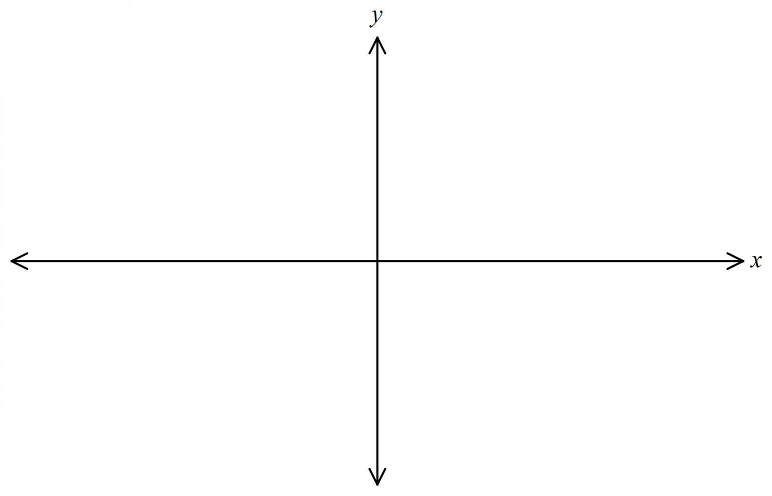(c) Sketch the general shape of the graph of $y=f(x)$ (3 marks)

Additional working space
Question number: __________________

© MAWA, 2018
This examination is Copyright but may be freely used within the school that purchases this licence.
- The items that are contained in this examination are to be used solely in the school for which they are purchased.
- They are not to be shared in any manner with a school which has not purchased their own licence.
- The items and the solutions/marking keys are to be kept confidentially and not copied or made available to anyone who is not a teacher at the school. Teachers may give feedback to students in the form of showing them how the work is marked but students are not to retain a copy of the paper or the marking guide until the agreed release date stipulated in the purchasing agreement/licence.

Published by The Mathematical Association of WA
12 Cobbler Place, MIRRABOOKA 6061

